1. Extact files from arffmerger.zip
2. Open arffmerger.exe

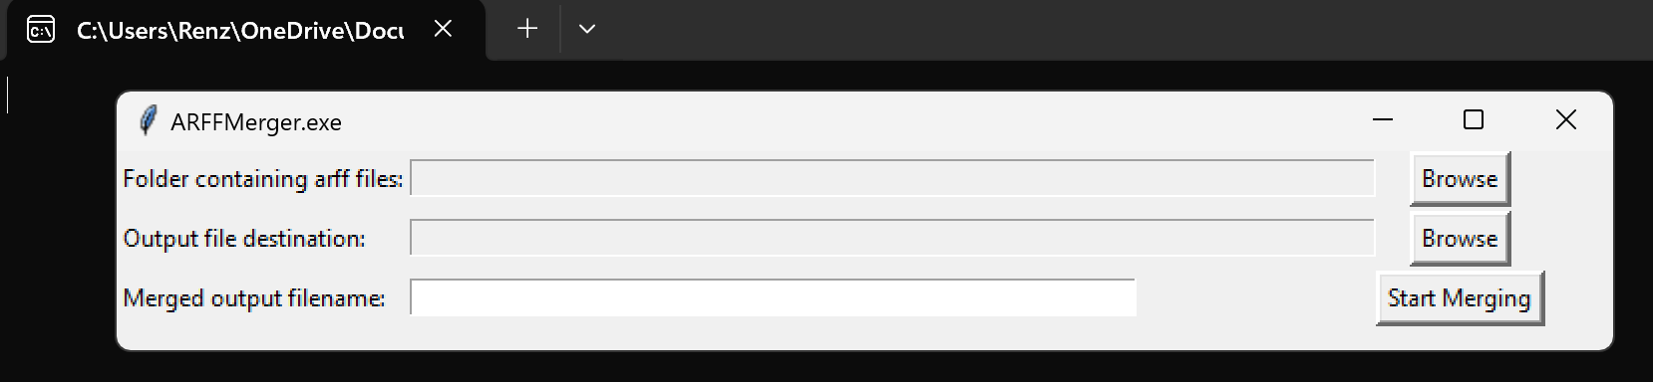

This is what it should look like when arffmerger.exe has been opened.

1. Click the browse button (circled in red) to choose the folder containing the arff files to be merged.

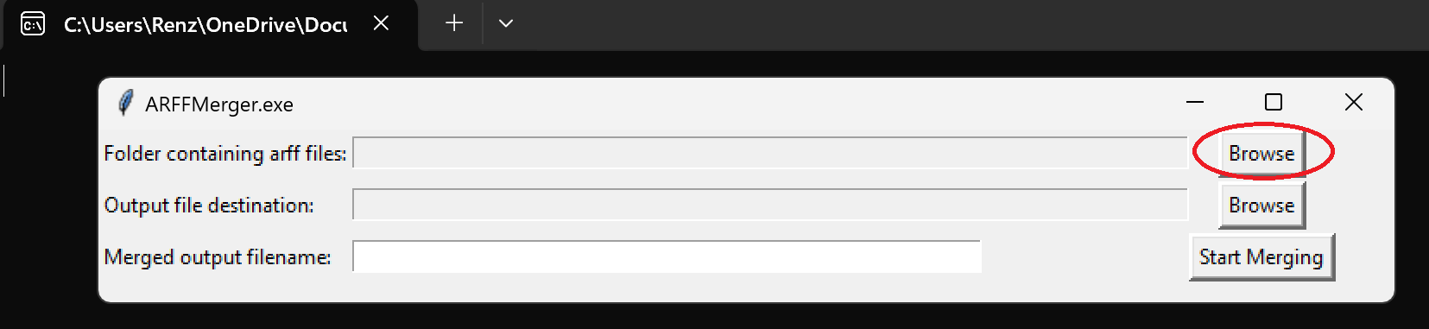

1. Navigate towards the folder containing the arff files to be merged. Select it and then click “Select Folder” located at the bottom right of the window.

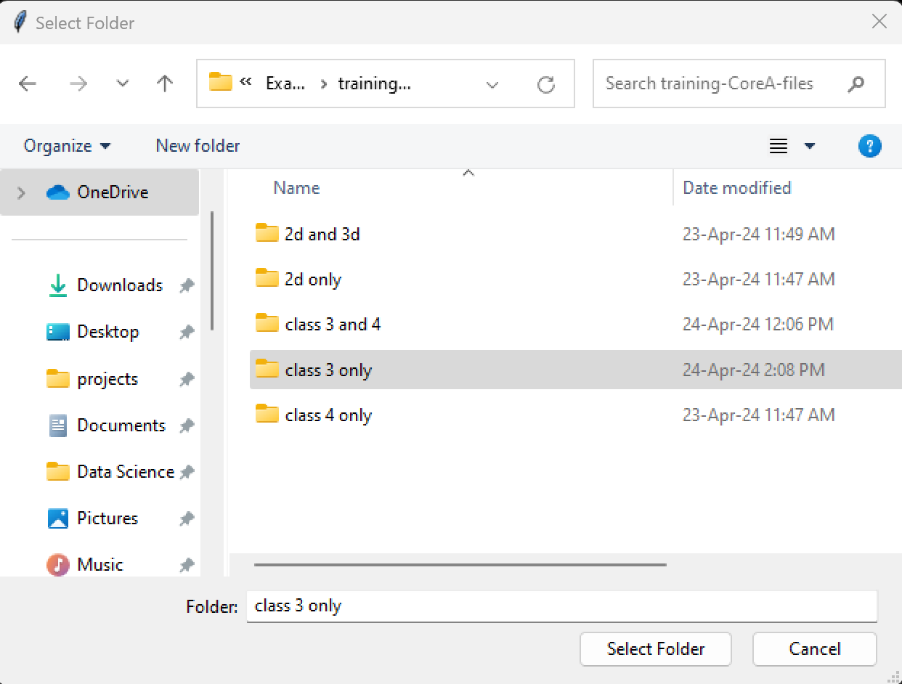

1. Click the second browse button (circled in blue) to select the folder where the final output merge file will be located.

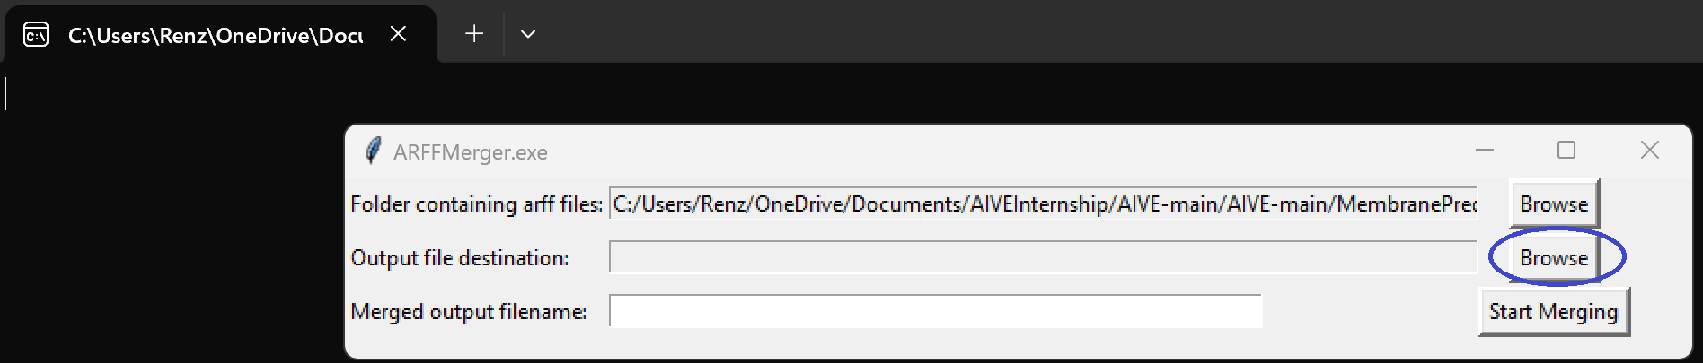

1. Navigate towards the folder where you want the output file to be stored. Select it and then click “Select Folder” located at the bottom right of the window.



1. Type in your desired filename for the output file in the white box (circled in yellow).

Note: Avoid putting in special characters like, !@#$%, in the filename, so the program doesn’t give an error message.

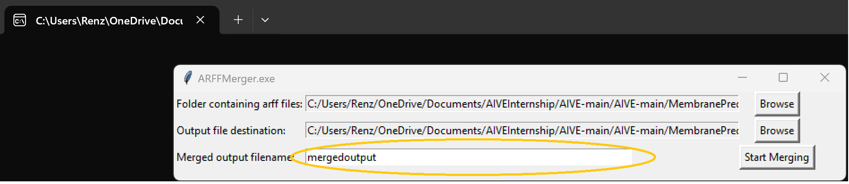

1. Click the “Start Merging” button to begin the file merging. After clicking the button, the window will disappear, and the merging process will begin.
2. If all the arff files in the chosen folder contain the equal number of classes and attributes, the merging is be successful, and this message will pop up:

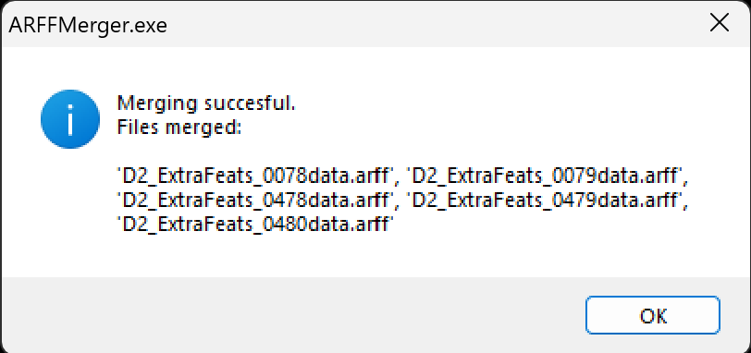

The final output file will be found on your chosen folder along with a txt file indicating the date the merge was done.

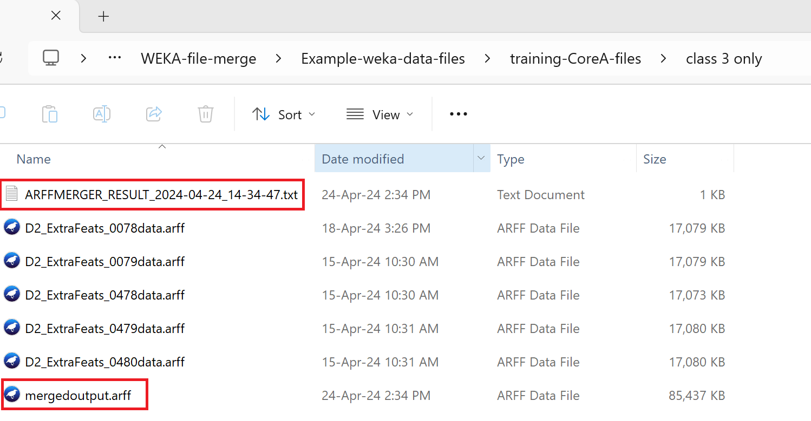

Opening the txt file will display the order of merging with the arff files. In this example, ‘D2_ExtraFeats_0078data.arff’ was first merged with ‘D2_ExtraFeats_0079data.arff’, then ‘D2_ExtraFeats_0478data.arff’, and so on.



1. If the arff files in the selected folder contain a different number of classes or attributes, merging will not proceed and error messages will pop up.

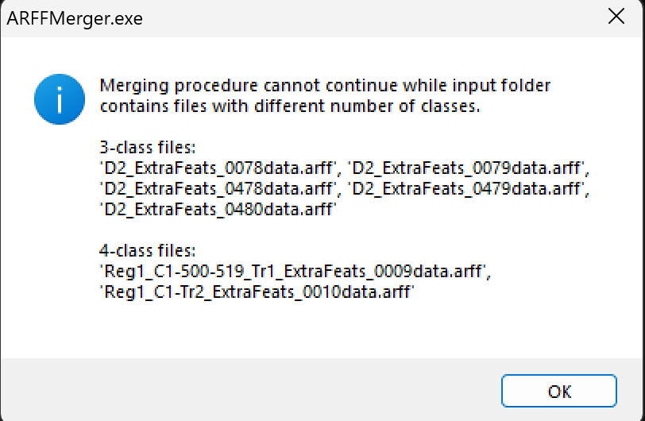

Error message that pops up when the folder contains different number of classes

A txt file also appears in the selected folder which contains the same message within the message box above.

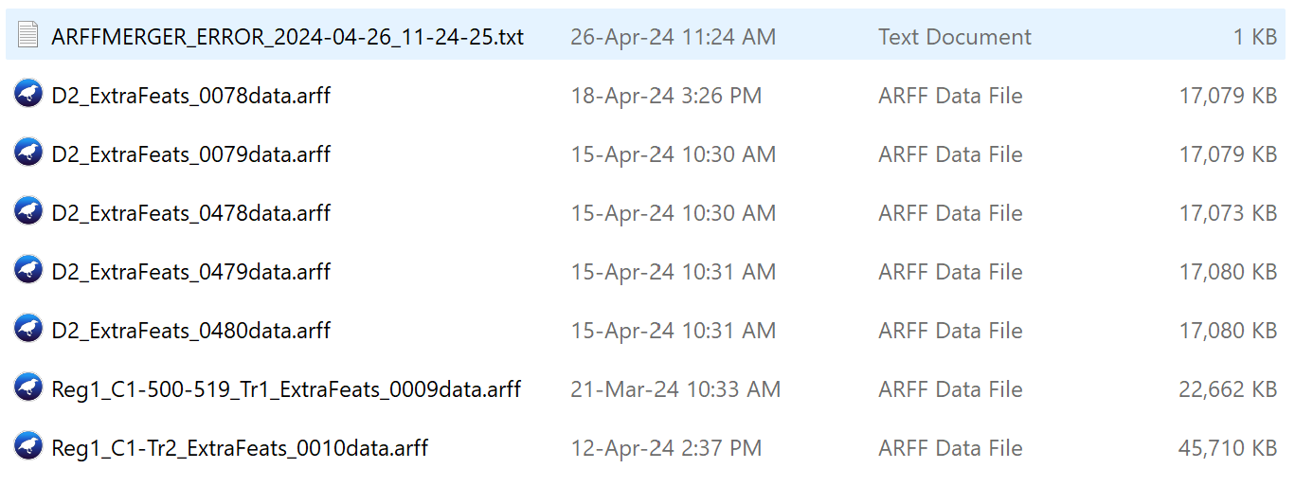

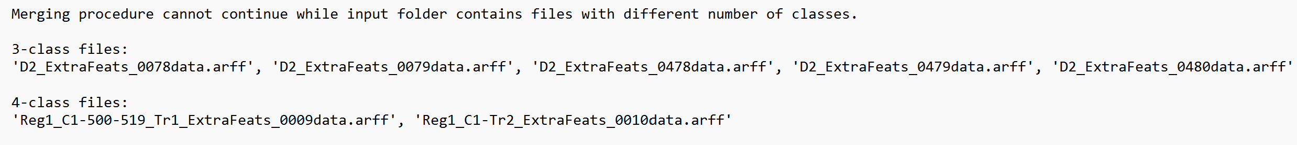

Lastly, an error message will also appear if the selected folder contains different numbers of attributes. The txt file containing the error message will also be found in the selected folder.